**2016 Pittsville Invite**

**Cross Country Meet**

When: Thursday August 25, 2016

Course Open 3:30 pm

Coaches Meeting 4:00 pm

Junior High 4:15 pm

Boys Varsity/JV 4:45 pm

Girls Varsity/JV 5:15 pm

Where: Pittsville Athletic Fields- by the elementary school. The course is flat, although one hill was added this year, with grass, some trails and several black top crossings, spikes may be used with caution but because we finish on the track, ¼” is the maximum length.

Teams: Wisconsin Rapids Assumption, Auburndale, Columbus Catholic, Marathon, Nekoosa, Spencer, Stratford and Pittsville

There is ample parking at the school.

Concessions available: The Panther Den will be open. There will be restrooms available as well.

Awards: Trophy for First place varsity team, medals to 1st 15 finishers Varsity boys and girls, and 1st 10 finishers junior high boys and girls.

Rosters:*.* Rosters must be submitted to Performance Timing by Noon on Tuesday August 23. Instructions for submitting your line-ups can be found at [www.performancetiming.com](http://www.performancetiming.com/) under the Coaches tab. Any questions can be referred to john@performancetiming.com or by phone at 715-215-7883. Changes may be made on race day.

Questions or Assistance:

Todd Sanken, A.D. (715) 897-3091 or [sanketod@pittsville.k12.wi.us](mailto:sanketod@pittsville.k12.wi.us)

Coach Bob Piotrowski (715)-897-2084 or [piotrrob@pittsville.k12.wi.us](mailto:piotrrob@pittsville.k12.wi.us)

(prefer the e-mail route or texting via phone)

Varsity Race Route:

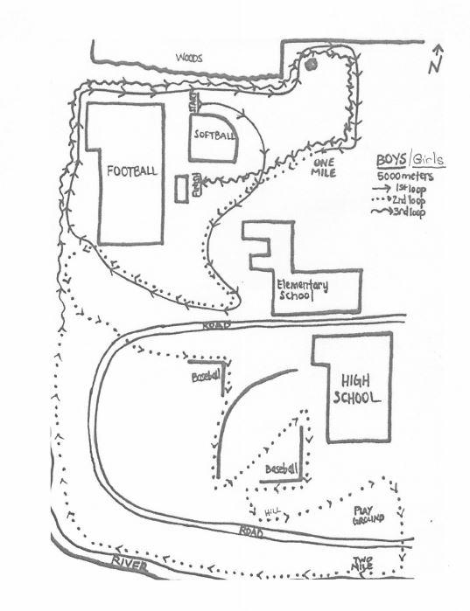

JH Race Route

